**Analysis of Cities with an Urban Growth Boundary**

Tyler Buhr, Jennifer Cain, Julia Revier, and Aja Tashjian

**1. Do cities with a UGB have more multi-unit structures and higher overall cost of housing than non UGB cities?**

In theory, because cities with a UGB have limits on development outside of city limits, one would think that the cities would have to build up thus have more multi-unit structures (Part A). In addition to this, because UGB cities have a set city limit, the demand within the city would be higher increasing the cost of housing because the city cannot grow out (Part B).

For the analysis of Part A, we examined the distribution of responses for single-unit and multi-unit structures for UGB and non UGB cities. The bar graph below shows the percent of responses for single-unit and multi-unit structures.

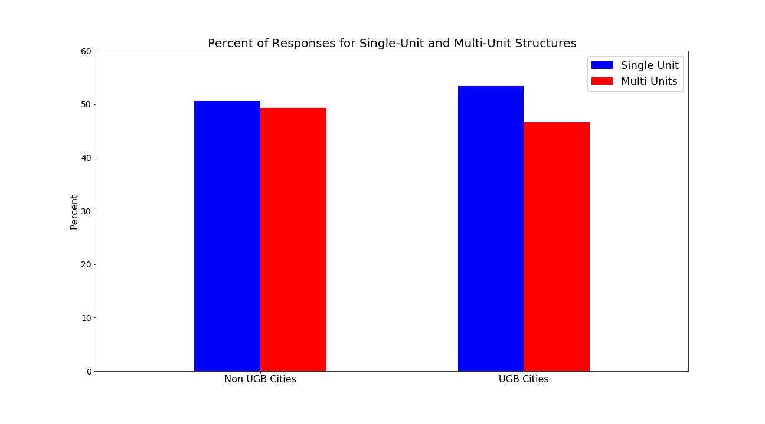

A chi-squared goodness of fit test was run on the number of responses for UGB cities. The expected values were calculated based on the ratio of single-unit to multi-unit structures in Non UGB cities, where single-unit structures were 50.66% of responses and multi-unit structures were 49.34% of the responses. The results of the chi-squared goodness of fit test showed that the differences seen in the distribution of responses for single-unit and multi-unit structures within UGB cities are statistically significant at the 5% significance level (critical value = 3.84, statistic = 5940.80, p-value < 0.05).

For the analysis of Part B, we examined the median housing costs for UGB and non UGB cities. The boxplot shows us that non UGB cities have a wider distribution of median housing costs than UGB cities. An independent t-test was conducted to determine if there is a difference between median housing costs between UGB cities and non UGB cities. The results of the t-test showed that there was insufficient evidence to conclude that a difference is present between median housing costs between UGB and non UGB cities (t-statistic = 1.79, *ɑ* = 0.05, p-value = 0.1057).

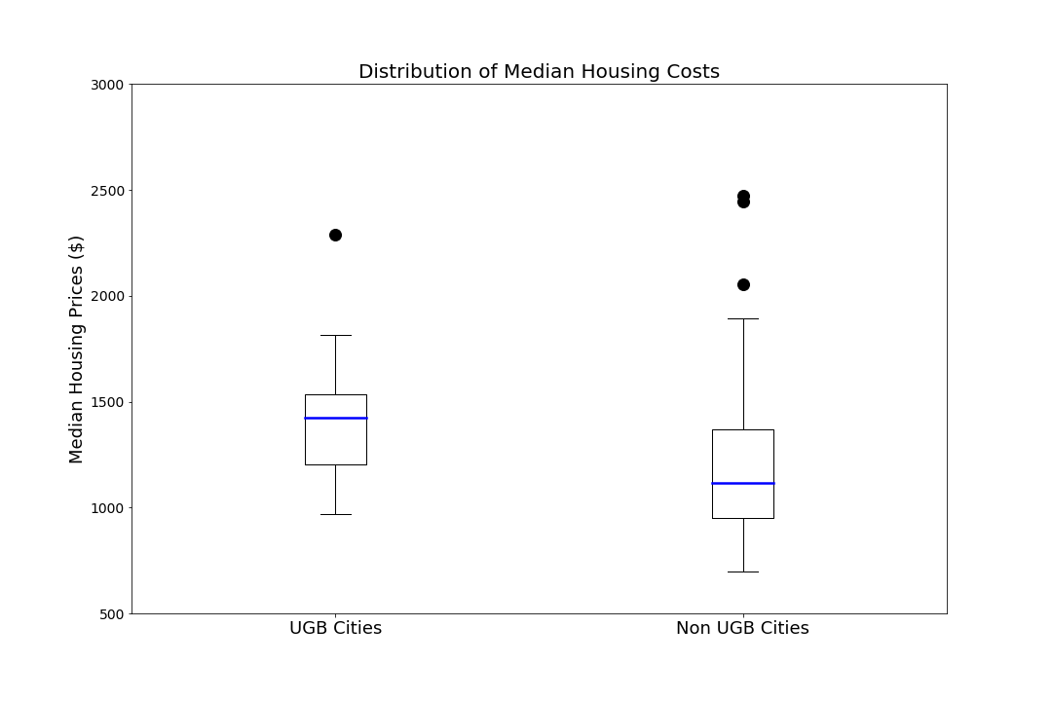

2. **Do Residents in UGB Cities use Public Transportation more than those in non-UGB Cities?**

As Urban Growth Cities limit their geographical expansion, it would be expected that that physical space is at a premium and that many residents of these cities would opt to use public transportation as parking space may be a very limited resource.  
 To address this question, we pulled the 2018 Annual Survey from the Federal Transit Administration National Database and compared the number of persons using public transportation (including walking, biking) against the number of persons who commute (drive their own vehicle or carpool).

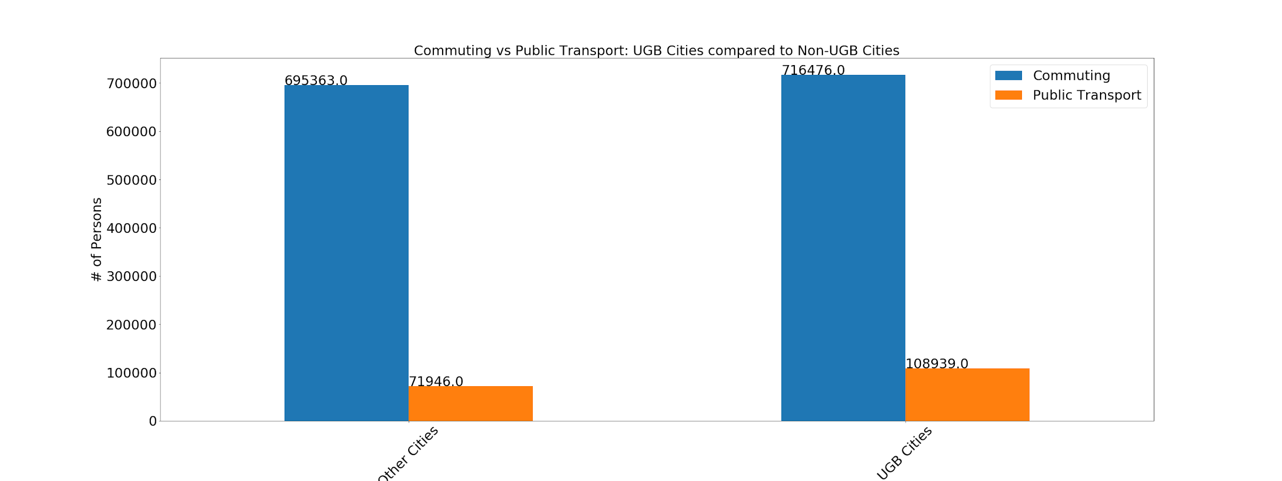

As predicted, the percentage of residents who use public transportation instead of commuting is almost twice in Urban Growth Cities as compared to the others, 13% as compared to 7%.

However, this analysis does not factor availability or access to public transportation which is potentially limited in rural areas and could impact the results.

**3. Do UGB cities have lower population growth than the top 100 US cities? Do they have lower population growth than the average US population growth?**

It would be expected that due to the land use limits on city growth, result in higher costs of living and fewer viable housing/living situations, which would result in smaller, or even negative population growth in UGB cities as manageable living decreases.

First, we compared the average populations of the Top 100 US cities to the UGB cities, for this comparison, the goal is that there is no significant difference in population sample sizes, ensuring that comparison of the population growth is not due to suburban growth and that the base populations are comparable. The average population for a UGB city was 486,092 and for a top 100 city 645,995. After performing an independent T-test, the p-value was found to be .21… This indicates that there is no statistically significant difference in the population sizes of our two samples, meaning they can be compared and tested for other variable differences.

Next, found the average population growth in each sample size, UGB and Top 100 Cities, these came out to be UGB = 0.58%, Top100 = 0.712%. Also found the national growth rate for the entire US, which was 0.62%. 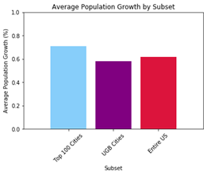

With these numbers, an independent T-test was performed between UGB cities and the Top 100 cities. The p-value was 0.67…, meaning we are unable to reject our null hypothesis and thus must reject our hypothesis that UGB cities will have a lower population growth rate.

For added curiosity, due to our class location in the Minneapolis/St. Paul area, we created a heat map to illustrate the growth rates of the UGB cities, to visualize which of the sample cities had the highest growth rate.

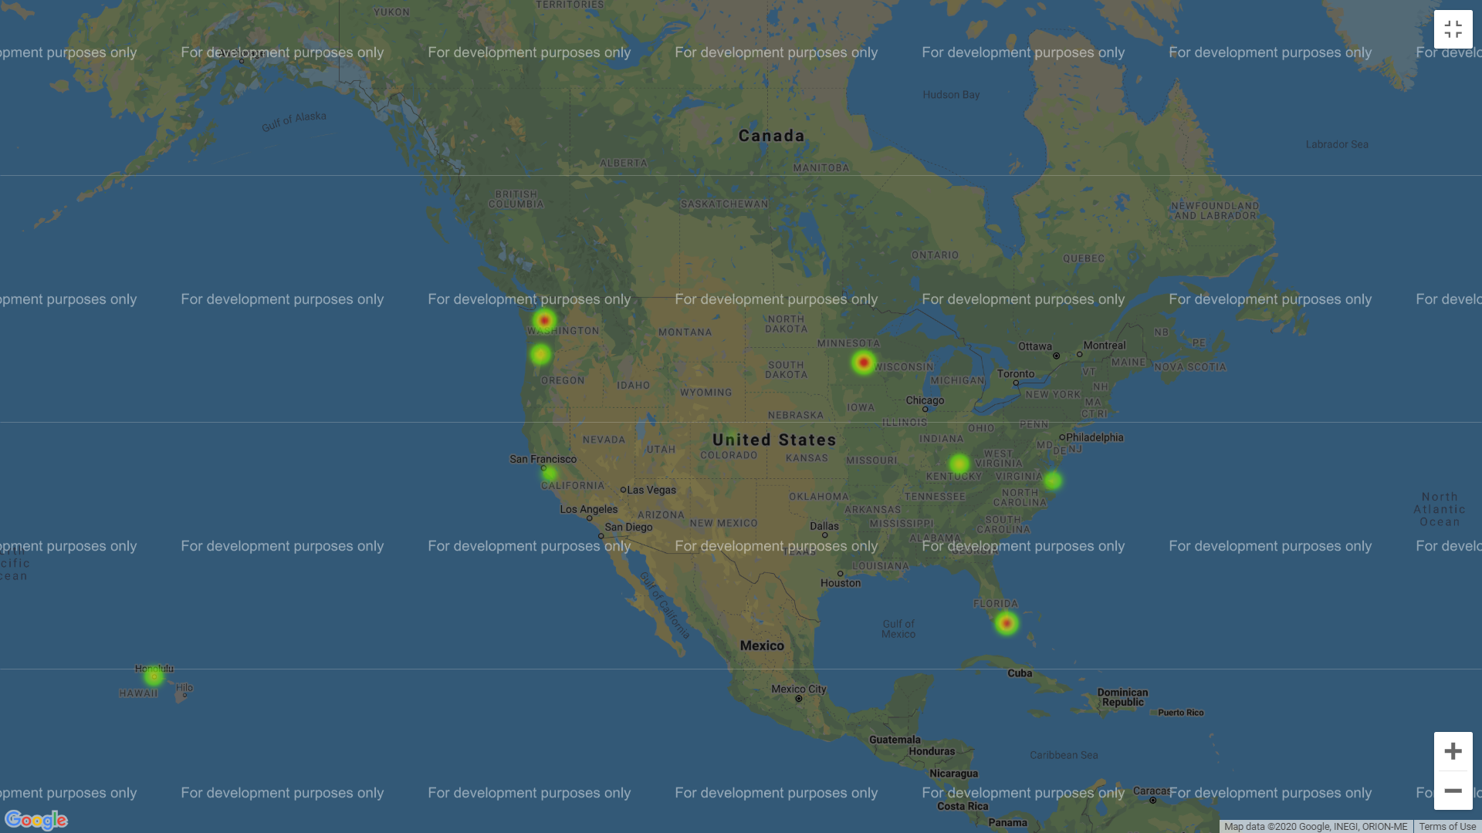

Due to limitations of showing data with negative weight values, a slider was added for color for the negative cities. Surprisingly, against our hypothesis, 7/10 UGB cities have population growth, with 5 (Seattle, Portland, Minneapolis, St. Paul, and Miami) having growth larger than the national average of 0.62%. Of these, the MSP area has the 3rd highest growth rate (1.8%), indicating the Twin Cities are an expanding and growing national city, go us!

**4. Do cities with a UGB have a higher population density than U.S. cities?**

In theory, because cities with an Urban Growth Boundary have limits on development outside of city limits, one would think that the cities would become more densely populated as development grows up and not out. During boxplot analysis we found that UGB cities had a slightly higher average population density (persons per km²) of 2346 than the overall largest U.S. cities (1915.5 ppk²).

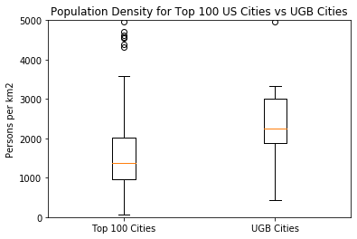

We also created a heatmap to geographically visualize the distribution of people. The blue markers on the map are UGB cities. The markers seem to correlate with denser cities, excluding New York City and downtown Los Angeles.



Overall, the population density between cities with a UGB and those without is not statistically significant. We determined this by running an independent t-test on the means of non UGB cities and UGB cities. We were not able to reject the null hypothesis that there is no difference in population density between the two as the p-value was 0.1016.